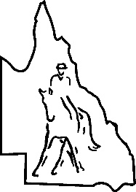
CABOOLTURE DRESSAGE GROUP INC.
P.O. Box 1398, Caboolture. 4510

PROXY FORM
ANNUAL GENERAL MEETING
SATURDAY 22nd February 2026

I ..........................................................................of.................................................................................
being a current 2025 Financial Member of the Caboolture Dressage Group Inc.

Appoint ..............................................................of...................................................................................
as my proxy to vote for me on my behalf at the Annual General Meeting of the association to be held on the 22nd day of February 2026.

Signed this .....................................................day of ................................................. 20

Signature ....................................................................................................................

Proxy votes must be received by the Secretary before the start of the Annual General Meeting which will be held on the 22nd day of February 2026.
Only current 2026 financial members can provide a proxy for the Annual General Meeting. Caboolture Dressage Group Inc. Social/junior members do not have voting rights.

Remember, your vote is important to maintain a continued high standard of performance within the Club.

